Krish Aggarwal 22BCS16370 IOT-FL-603

1763.[Longest Nice Substring](https://leetcode.com/problems/longest-nice-substring/description/)

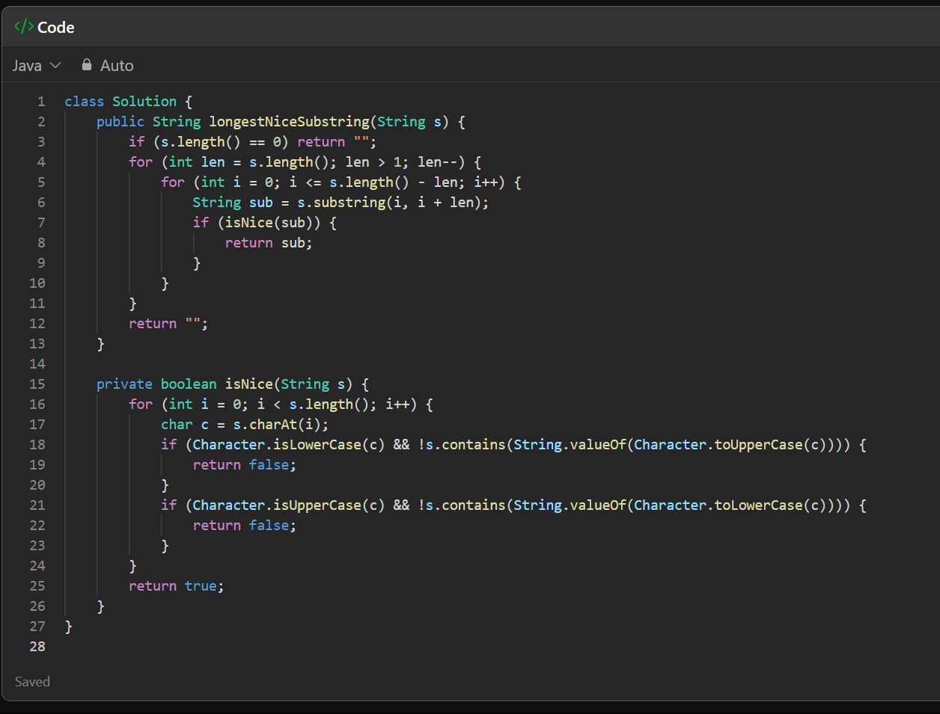

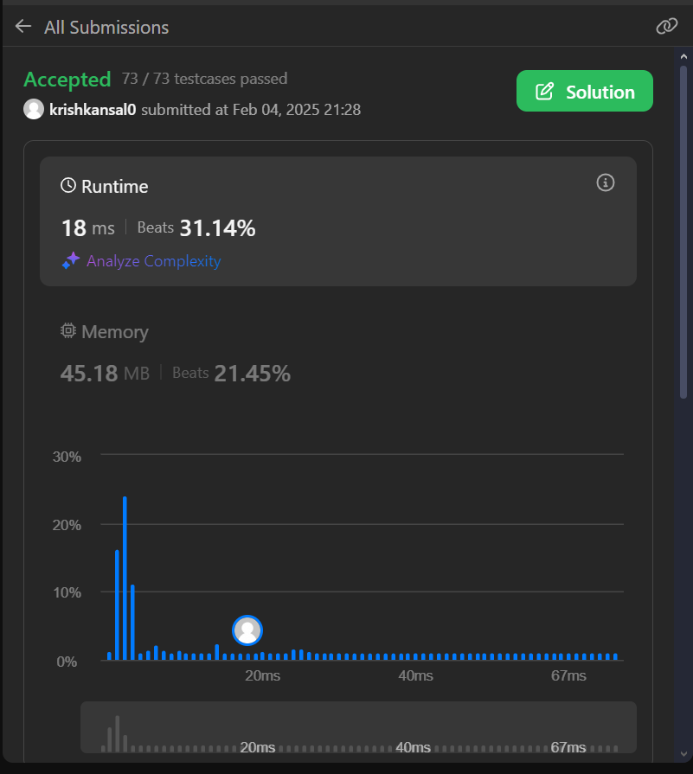

190.[Reverse Bits](https://leetcode.com/problems/reverse-bits/description/)

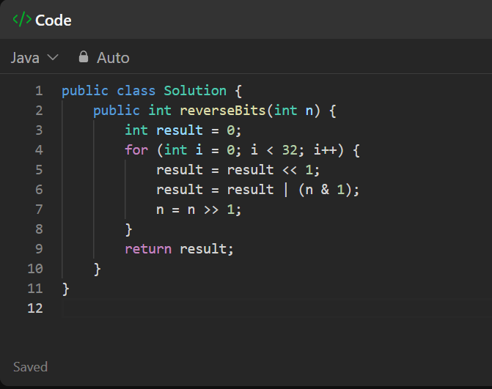

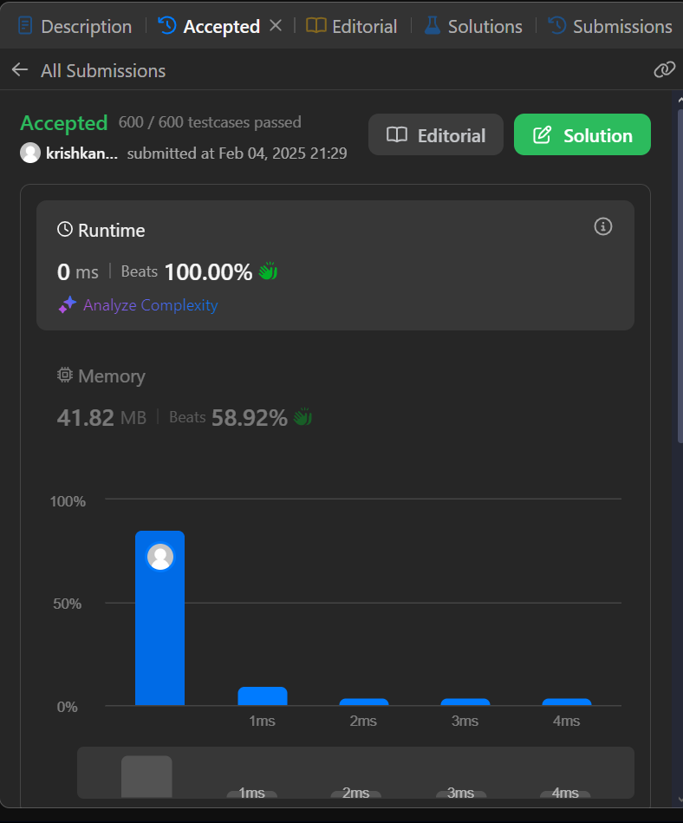

191.[Number of 1 Bits](https://leetcode.com/problems/number-of-1-bits/description/)

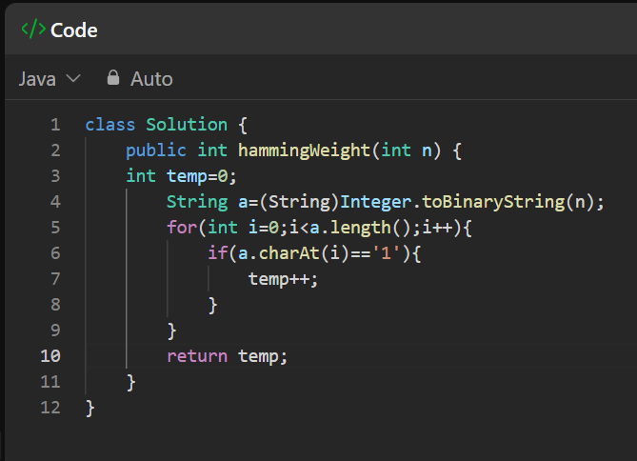

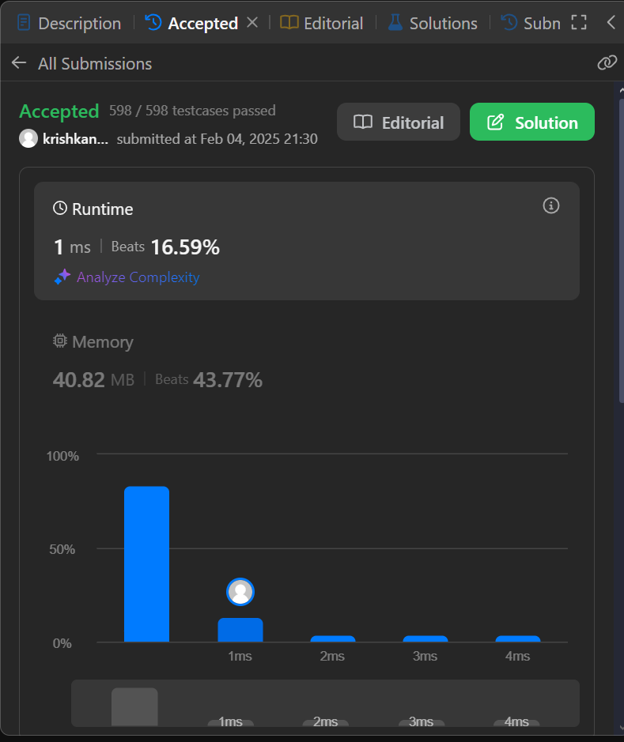

53.[Maximum Subarray](https://leetcode.com/problems/maximum-subarray/description/)

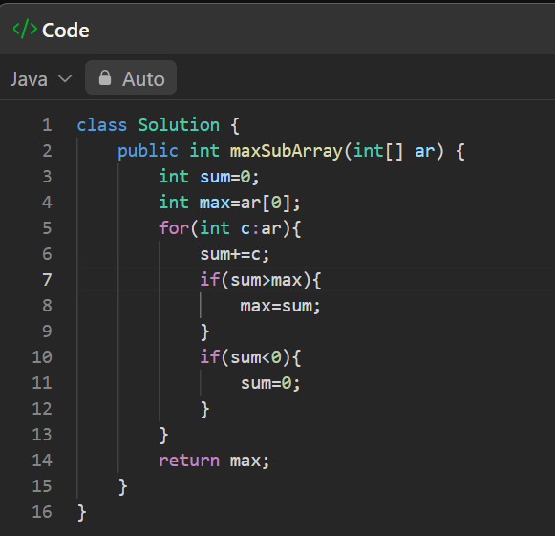

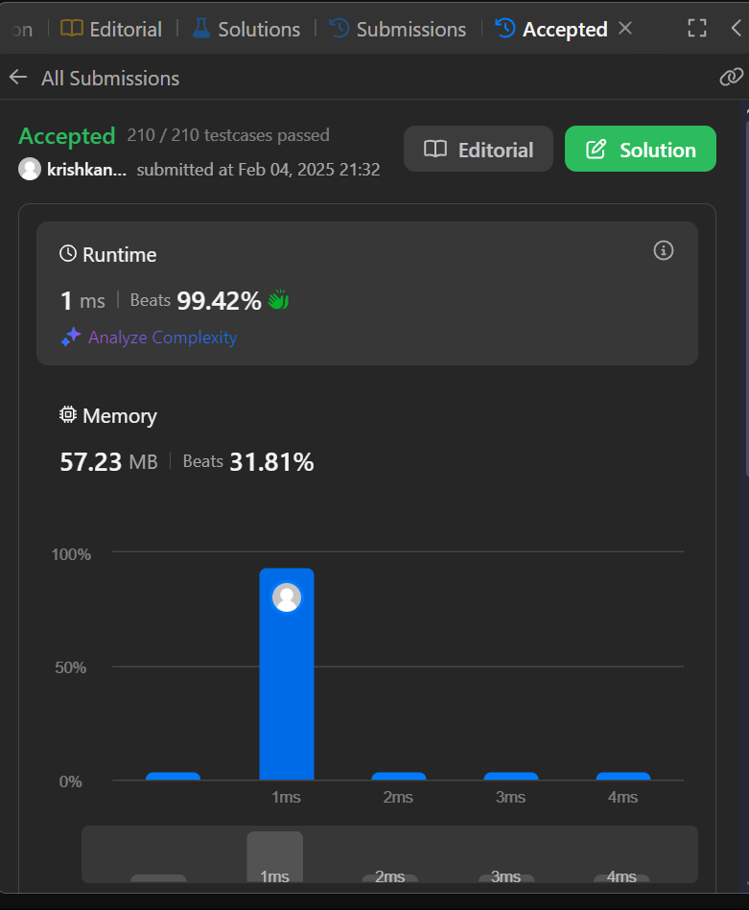

240.[Search a 2D Matrix II](https://leetcode.com/problems/search-a-2d-matrix-ii/description/)

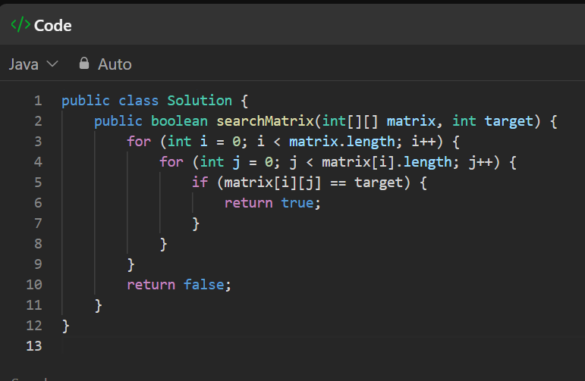

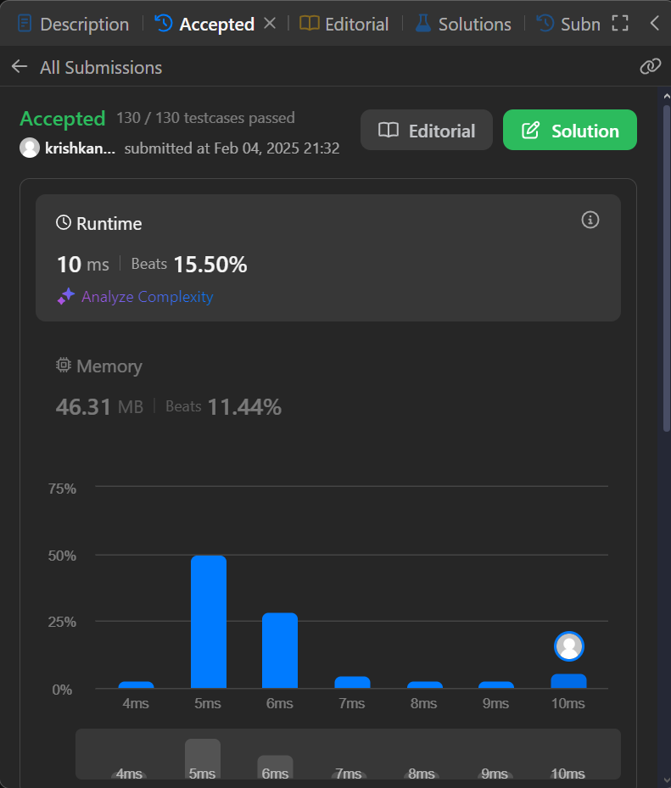

372.[Super Pow](https://leetcode.com/problems/super-pow/description/)

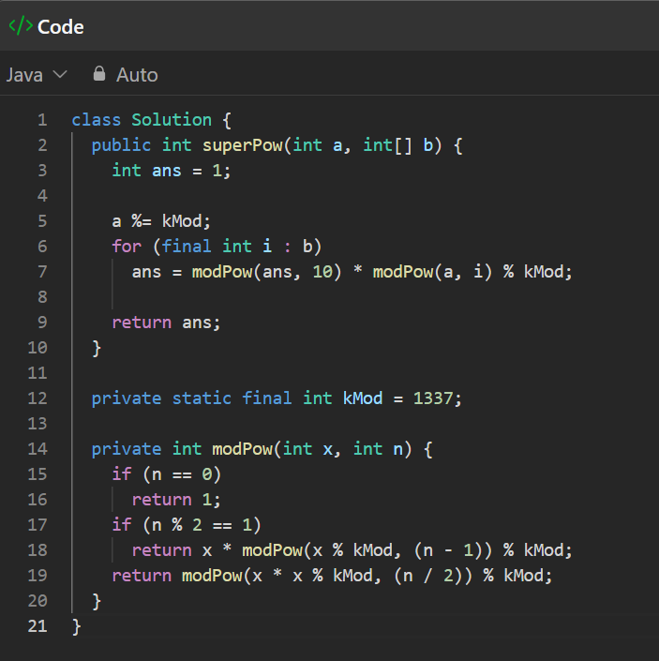

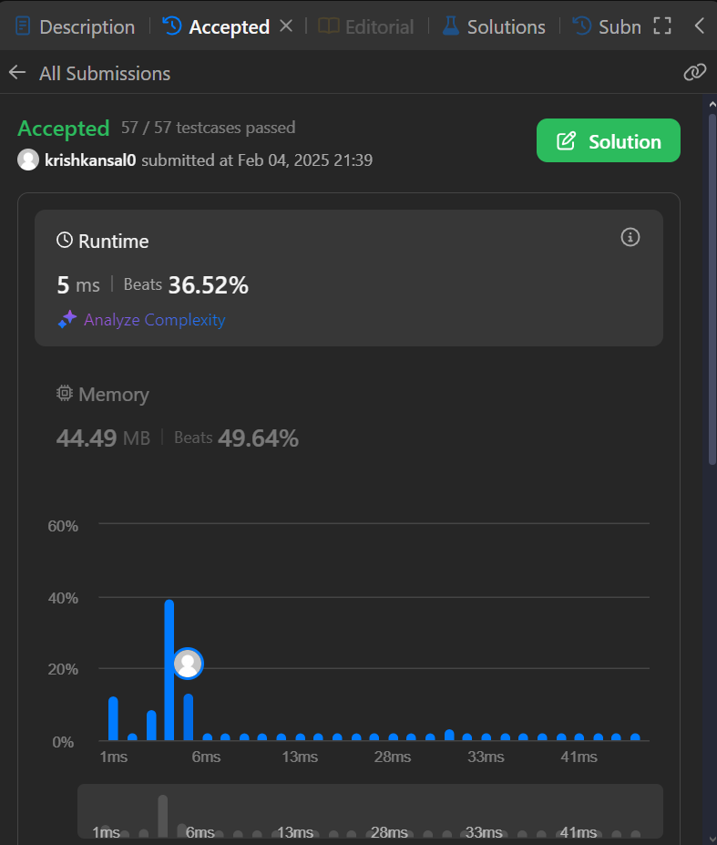

932.[Beautiful Array](https://leetcode.com/problems/beautiful-array/description/)

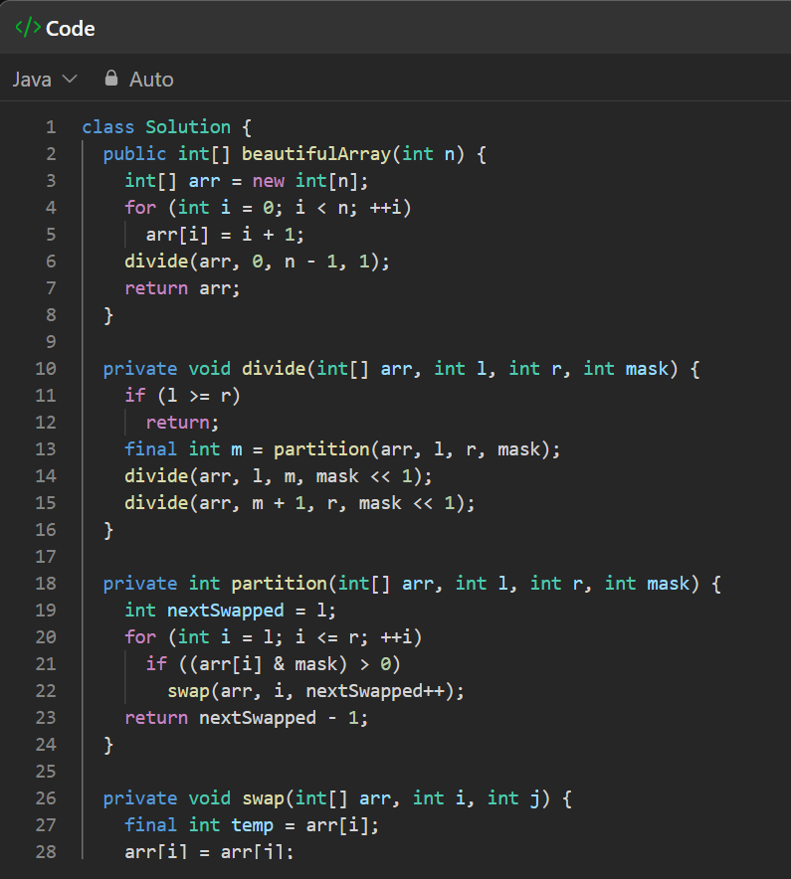

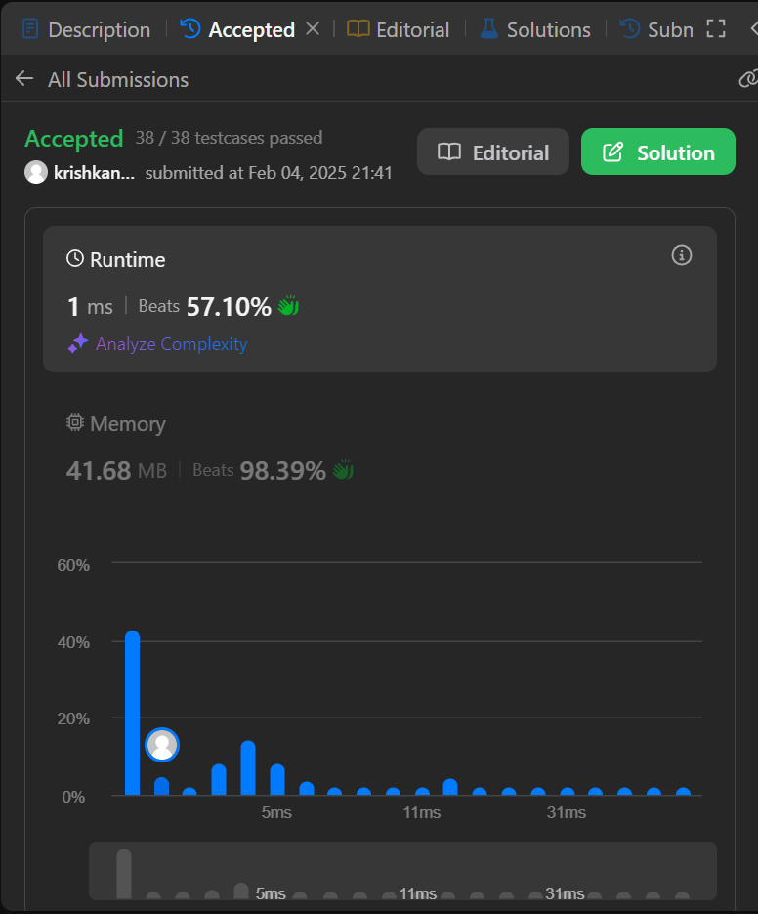

88.[Merge Sorted Array](https://leetcode.com/problems/merge-sorted-array/description/)

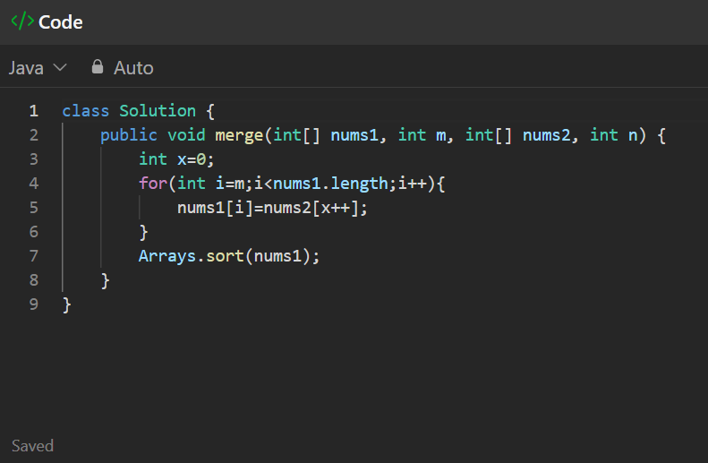

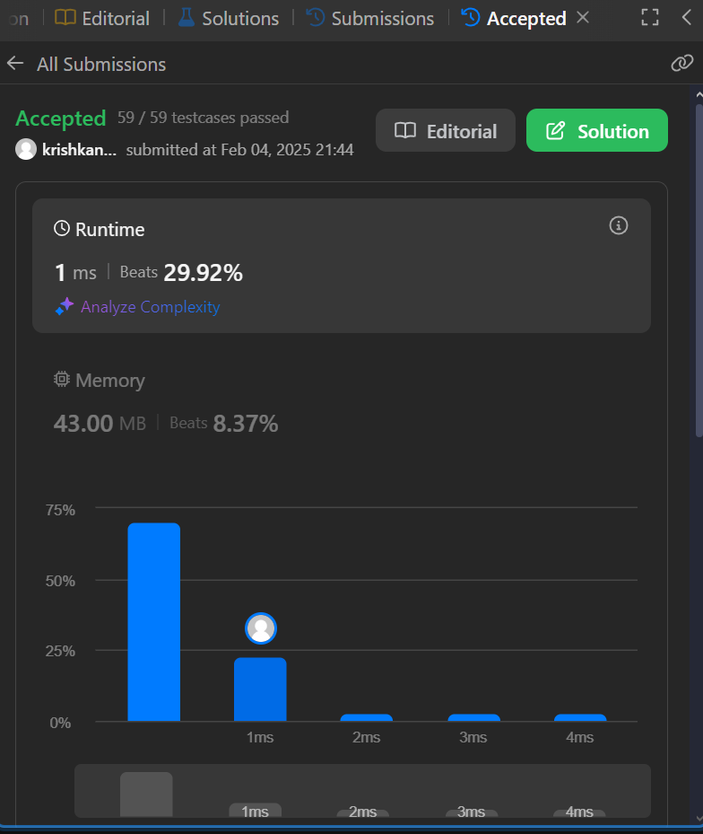

278.[First Bad Version](https://leetcode.com/problems/first-bad-version/description/)

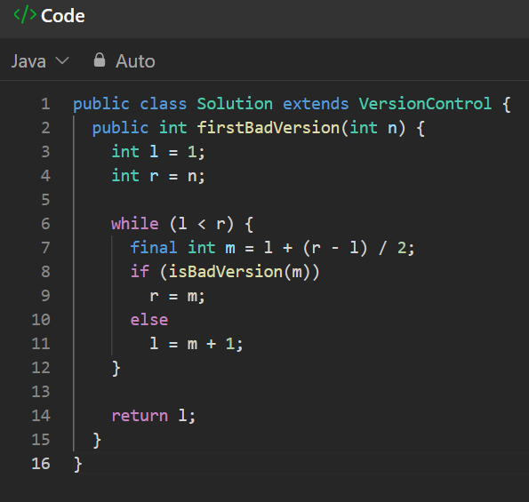

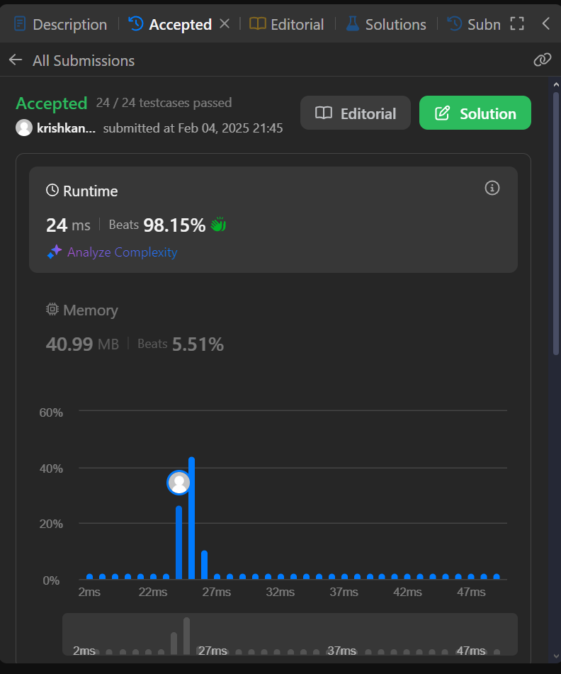

75.[Sort Colors](https://leetcode.com/problems/sort-colors/description/)

